**Exercise 6: Online Bookstore - Exception Handling in REST Controllers**

Business Scenario:

Implement a global exception handling mechanism for the bookstore RESTful services.

1. **Global Exception Handler:**

* I created a **GlobalExceptionHandler** class using **@ControllerAdvice** and defined methods to handle various exceptions and return appropriate HTTP status codes

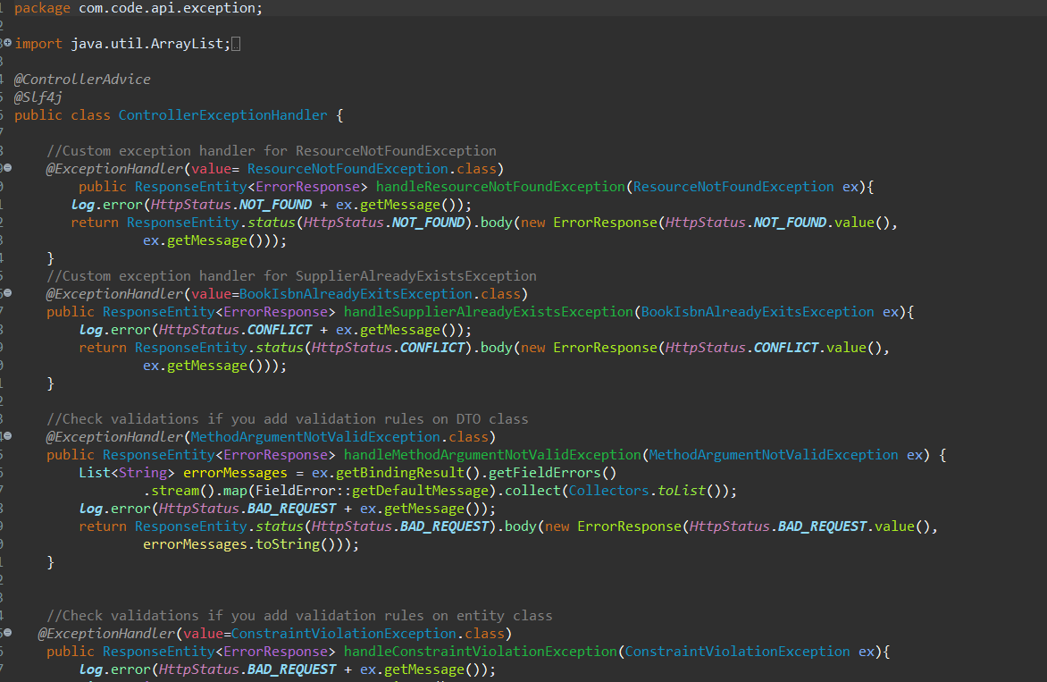

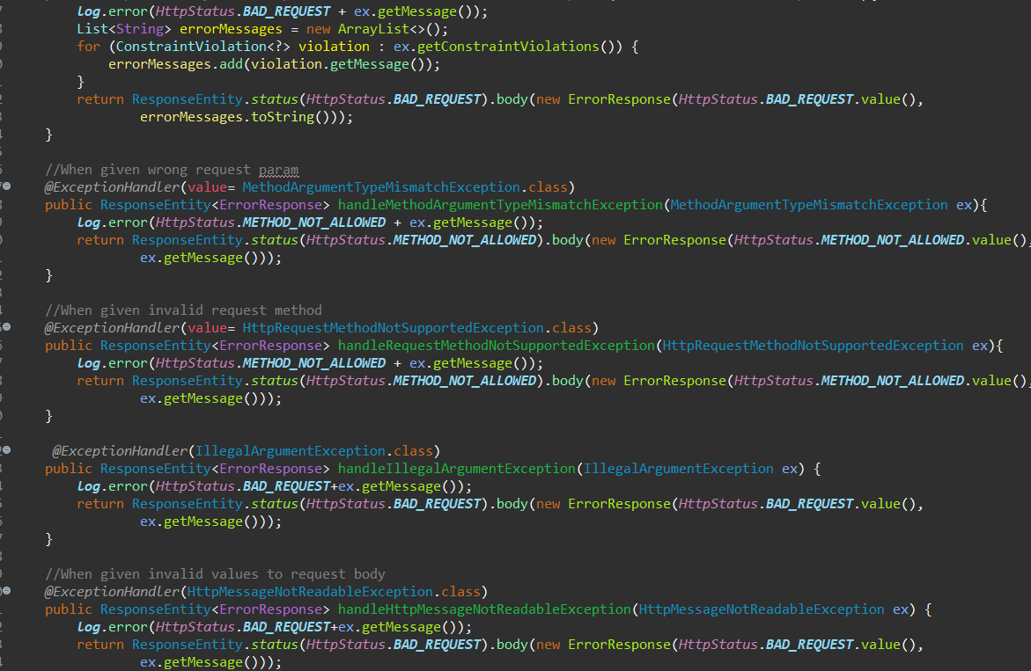

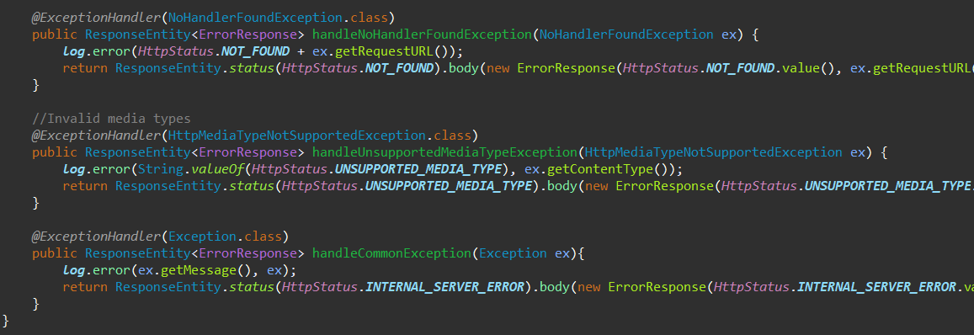

I defined exception classes as well:

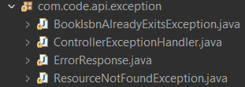

**Output:**

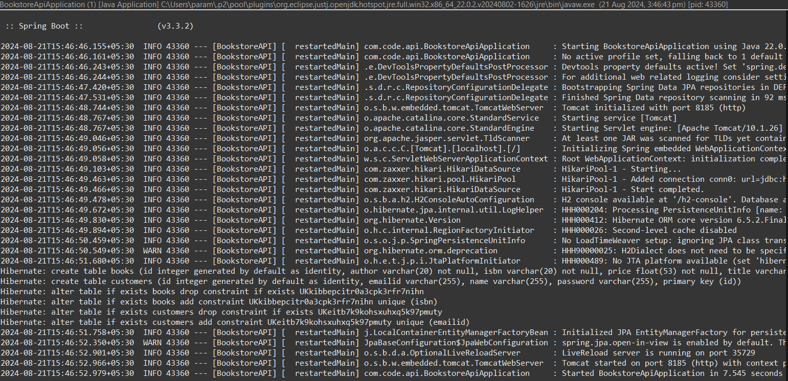

Opening Postman and performing the operations to check exception handling:

